**San Francisco Bay University**

**MATH201 - Calculus-I**

**Homework Assignment #2**

**Due day: 10/3/2024**

**Instruction:**

1. **Push the answer sheet to Github in word file**
2. **Overdue homework submission could not be accepted.**
3. **Takes academic honesty and integrity seriously (Zero Tolerance of Cheating & Plagiarism)**
4. Plot each following group of functions in one graph respectively by **Excel**, covering the appropriate domain of *x* and *y.*

The graph shows that some lines shoot up really fast as we move right (like y = ex and y = 8x), which means they grow quickly. Other lines go down towards the bottom as we move right (like y = e{-x} and y = 8{-x}), which means they shrink down close to zero but never actually touch it.

The lines for y = ex and y = e{-x} look like mirror images of each other. This is cool because it shows us how one line going up can have a matching line going down the same way, just on the other side.

**Main Point:** This graph is a cool way to see how some things can either grow really fast or shrink really fast, and it’s important to know this because it helps us understand stuff like saving money, growing plants, or even how stars work.

This graph clearly shows how each function decreases as xxx increases, with each function approaching zero but never actually reaching it. The graph covers the domain from x=0, x=10, providing a good range to observe the rapid decay, especially for lower bases like 0.1 and 0.3.

1. Given , prove that and verify it by the plot in **Excel.**

Given f(x) = 10x, compute f(x+h) = 10{x+h}

Find f(x+h) −f(x)= 10^{x+h} – 10x.

So

Using the exponential rules, 10^{x+h} = 10x ⋅ 10h.

So

f(x+h) − f(x)=10x⋅10h −10x.

Factor out 10x, yielding 10x(10h - 1).

1. Compare the functions and by plotting curve in **Excel** and which function grows more rapidly when *x* is large? And prove it mathematically.

As seen in the graph, the function g(x)= 5x (in red) grows significantly faster than f(x)=x5 (in blue) as x increases.

**Differentiate the numerator:**

(x5) = 5x4 ,  (5x) = 5xln(5)

**First application of L'Hôpital's Rule**:

Again, we have an indeterminate form ∞/∞​:

**Differentiate the numerator:**

(5x4) = 20x3

**Differentiate the denominator:**

(5xln(5)) = 5x(ln(5))2

**Now we apply L'Hôpital's Rule again:**

**As x approaches infinity, the term 5x in the denominator grows without bound, leading to:**

= 0 = 0

This implies that f(x)=x5 grows much slower than g(x)=5x as x becomes large. Therefore, we conclude that g(x) grows more rapidly than f(x) for large values of x.

1. Plot the function in **Excel**. And then prove that is an odd function.

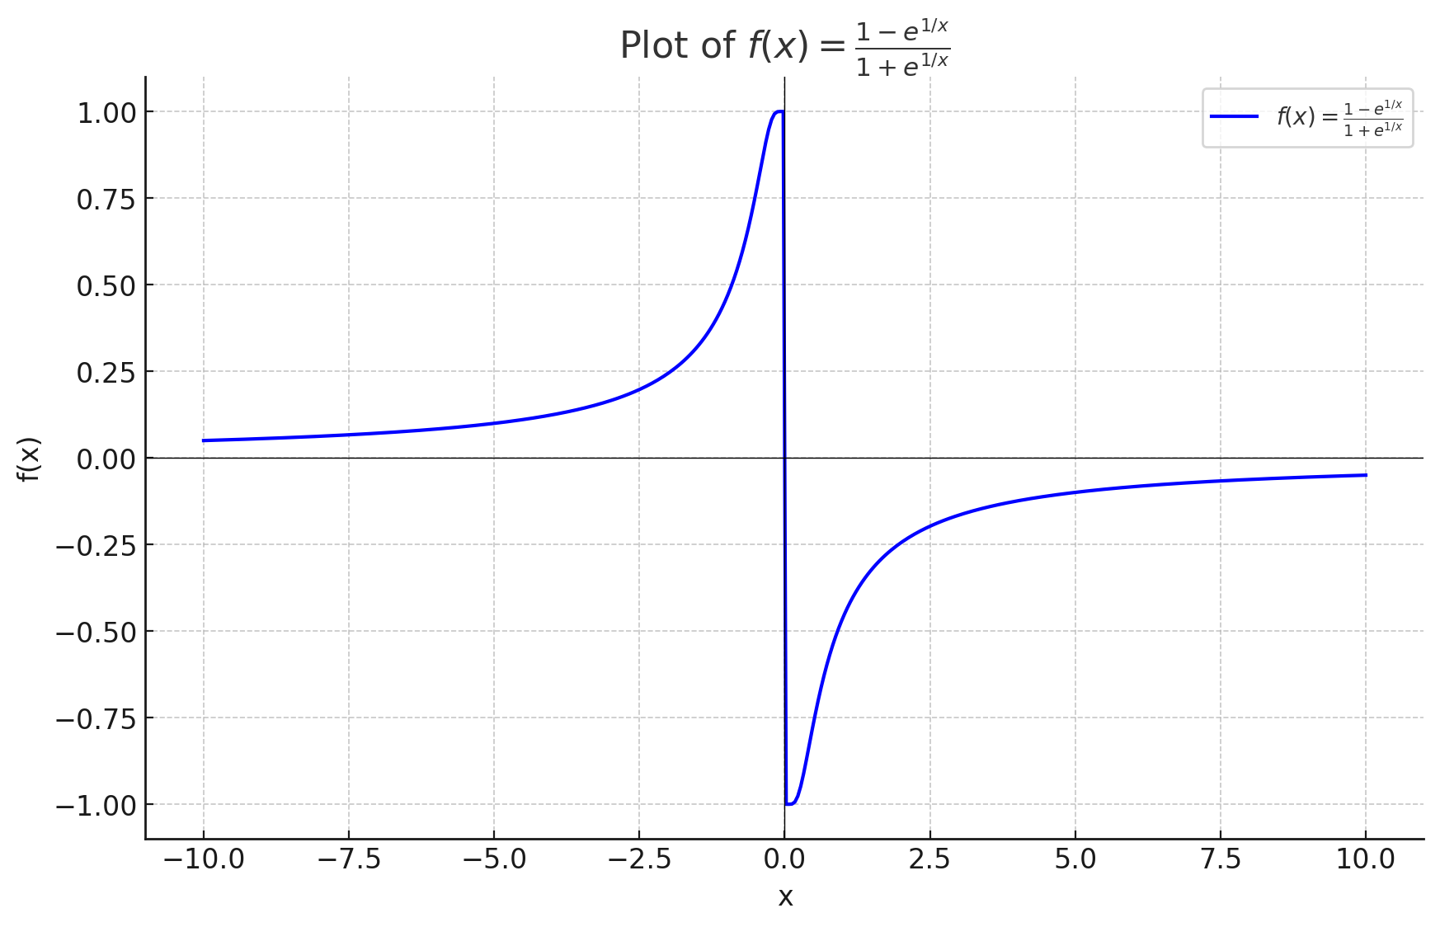

Here is the plot of the function f(x) = ​​. The graph displays how the function behaves over a range of x values from -10 to 10, carefully avoiding x = 0 where the function would be undefined.

**Proof that f(x) is an Odd Function:**

An odd function satisfies the property that f(−x) = −f(x) for all x.

**Given Function:**

**Compute f(−x):**  =

**Show that f(−x) = −f(x):**

We need to prove: f(−x) = − () = =

**Compare f(−x) and −f(x):**

Now, we note that: f(-x) = , -f(x) =

Multiply numerator and denominator of f(−x) by to standardize the expression:

= = - f(x)

This transformation confirms that: f(−x) = − f(x).

So,

The function f(x) = ​​ is indeed an odd function. The calculations affirm that substituting −x for x results in the negation of the original function, which is a defining characteristic of odd functions.

1. For the parametrized function
   1. where a > 0. How does the graph change when b changes by showing a group of curves by **Excel**?

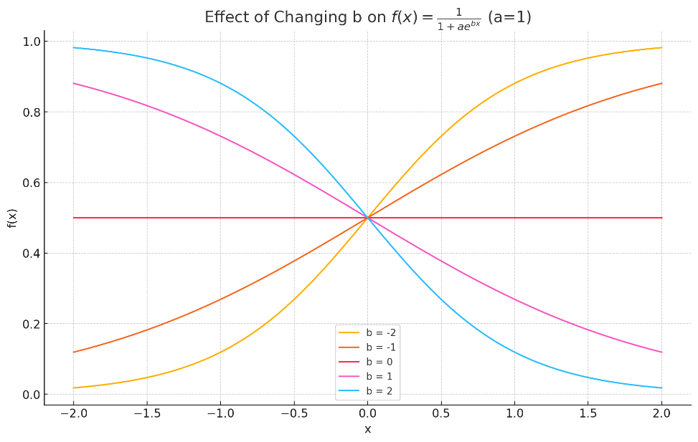

**Effect of Changing b:**

* The plot shows different curves for each value of b.
* When b is positive, the function decays more steeply and approaches zero as x increases. As b increases in magnitude (positive), this steepness becomes more pronounced.
* When b is negative, the function grows more steeply from zero as x decreases. Higher negative values of b lead to a sharper rise.
* When b=0, the function transforms to a horizontal line because e0=1, thus f(x) becomes ​, which is a constant for all x.
  1. How does it change when *a* changes in **Excel**?

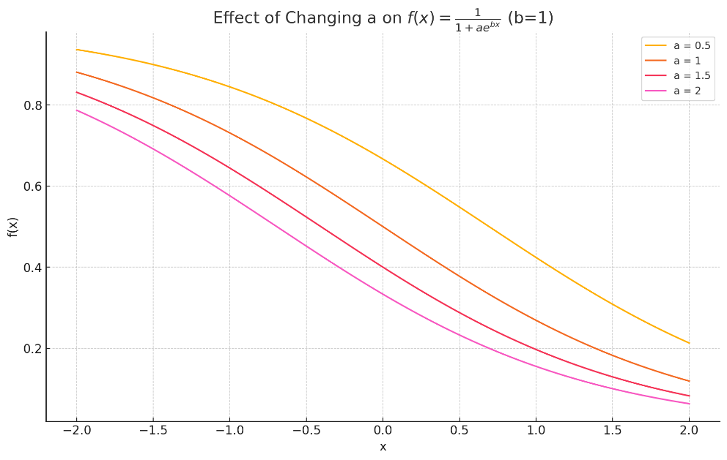

**Effect of Changing a:**

* Changing a affects the y-value at x=0 and modifies how the function approaches its asymptotes.
* Higher a values result in the function starting closer to zero at x=0 and increasing more steeply as x moves away from zero.
* The increase in a, flattens curves more towards zero for negative x values and makes it approach 1 more gradually for positive x values.

1. If , find expression. And that, plot and in one graph by **Excel**

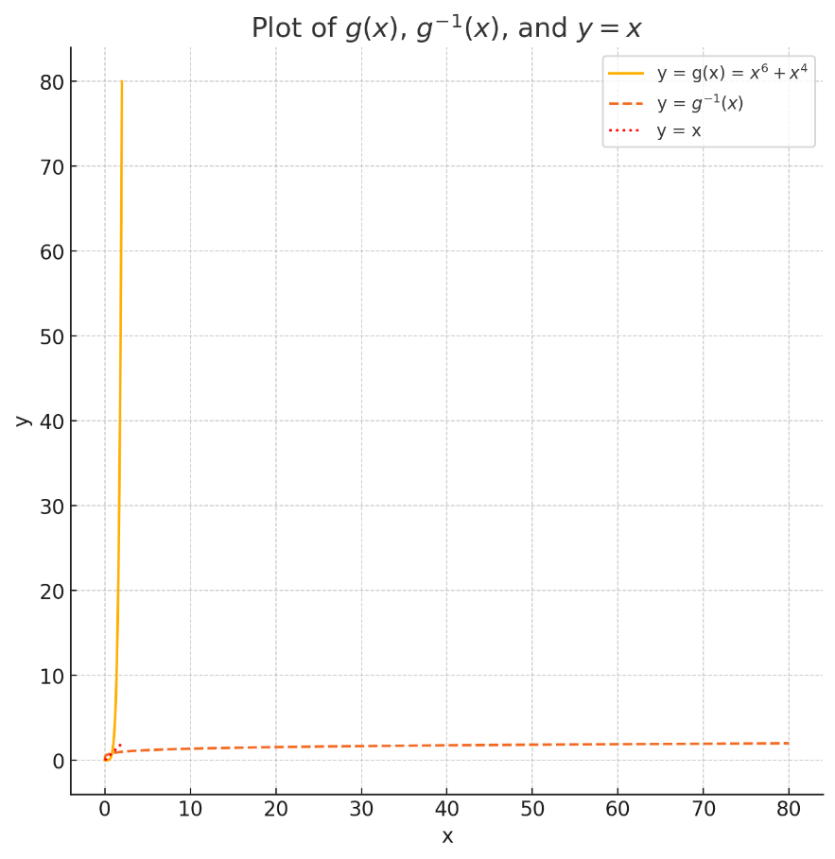

**y=g(x)**: This curve (orange solid line) represents the original function. Due to the powers of 6 and 4 in the equation, it grows rapidly as x increases.

**y=g−1(x)**: The inverse function (orange dashed line) mirrors the original function along the line y=x. It essentially swaps the x and y values of the original function.

**y=x**: This line (red dotted line) is a reference that shows the point at which functions and their inverses would intersect if they are perfect inverses of each other.

1. When a camera flash goes off, the batteries immediately begin to recharge the flash’s capacitor, which stores electric charge given by

(The maximum charge capacity is Q0 and t is measured in seconds.)

* 1. Find the inverse of this function and explain its meaning.

To find the inverse Q-1(t), we need to solve the equation for t in terms of Q(t).

Given: Q(t)=Q0(1-)

**Solve for t**:

**Rearranging the equation gives:**  = 1-

**Isolate the exponential term**: = 1 -

**Take the natural logarithm of both sides: -** = ln (1-

**Multiply through by -a:** t = -a ln(1-

**Inverse Function**: g-1(Q) = -a ln (1 -

The inverse function g-1(Q) represents the time t required to reach a certain charge Q in the capacitor. It indicates how long it takes to achieve a specified level of charge based on the decay of the exponential function, which is characteristic of charging circuits.

* 1. How long does it take to recharge the capacitor to 90% of capacity if a = 2 showing in the plot by **Excel**?

**Calculate Q for 90% of maximum capacity**: Q=0.9Q0

**Substituting into the inverse function**: t = -a ln(1- = -a ln(0.1)

**Given a=2**: t = -2ln(0.1)

For a=2, the time required to recharge the capacitor to 90% of its maximum capacity is approximately:

t≈4.61 seconds